|  |  |
| --- | --- |
| **EWULogo.png** | **EAST WEST UNIVERSITY** |
| **Department of Computer Science and Engineering** |
| **B.Sc. in Computer Science and Engineering Program** |
| **Mid Term II, Summer 2020** |

|  |  |
| --- | --- |
| **Course:** | **CSE246 (Algorithms), Section - 1** |
| **Instructor:** | **Taskeed Jabid** |
| **Full Marks:** | **25** |
| **Time:** | **1 Hour and 15 Minutes** |

**Note:** There are SIX questions, answer ALL of them.

1. What will be effect on m and s array if < is replaced by <= in line no 11 of the following pseudocode. Will the content of the arrays will be same or will be changed due to this modification? Explain your reason.

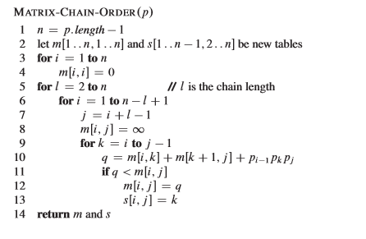

1. What is the relaxation process in calculating shortest path in a weighted graph? Explain the motivation behind the relaxation process and also write down the code of the relaxation.
2. Write down the pseudocode for finding longest common subsequence of two strings.
3. If you have been asked to solve the 0/1 Knapsack problem. If the best solution can be achieved in multiple ways with different number of items. In this circumstance, the classical method will provide which solution – solution with most items, solution with least items or any random one. Justify your answers. Also show how can you modified the algorithm to get other two answers.
4. The following code is executed with some value of the knapsack problem. Here W = knapsack size, wt is weight of the items, val is value of the items and n is number of items. After execution the content of the S array is also given. Analyzing this information and write down which item(s) are selected and whether knapsack is fully or partially filled after the process.

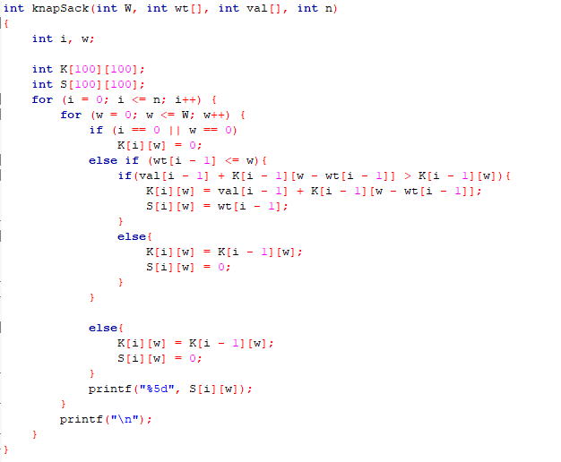

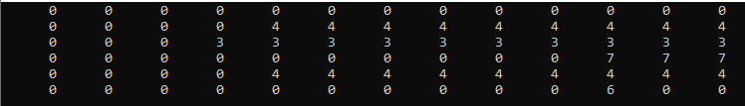

1. Write down the LCS table of two string – one string must be longest word of your name and another string may be any one your friend’s name. [Try to ensure that no name is less than five character in length]